|  |
| --- |
| Name: **M.T.D Salagado** |
| Student Reference Number: **10707355** |



|  |  |  |
| --- | --- | --- |
| Module Code: **SOFT255SL** | Module Name: **Software Engineering for theInternet using Java** (20/AY/AU/M) | |
| Coursework Title: **NSBM Canteen Management System** | | |
| Deadline Date:  **Tuesday, 1st Dec 2020** | | Member of staff responsible for coursework:  **Ms. Sulari Fernando** |
| Programme:  **BSc (Hons) Software Engineering – Plymouth UK** | | |
| Please note that University Academic Regulations are available under Rules and Regulations on the University website [www.plymouth.ac.uk/studenthandbook](http://www.plymouth.ac.uk/studenthandbook). | | |
| Group work: please list all names of all participants formally associated with this work and state whether the work was undertaken alone or as part of a team. Please note you may be required to identify individual responsibility for component parts.   |  |  | | --- | --- | | 10707355 | M.T.D Salgado | | 10707271 | Jayawardene Arachchige Ridmi | | 10707188 | Wakwella Dushmantha | | 10707286 | Muthupahane Gedara Methma | | 10707275 | L.D Mandira |   ***We confirm that we have read and understood the Plymouth University regulations relating to Assessment Offences and that we are aware of the possible penalties for any breach of these regulations. We confirm that this is the independent work of the group.***  Signed on behalf of the group: | | |
| Individual assignment: ***I confirm that I have read and understood the Plymouth University regulations relating to Assessment Offences and that I am aware of the possible penalties for any breach of these regulations. I confirm that this is my own independent work.***  Signed : | | |
| Use of translation software: failure to declare that translation software or a similar writing aid has been used will be treated as an assessment offence.  I *have used/not used translation software.  If used, please state name of software………………………………………………………………… | | |
| **Overall mark _____% Assessors Initials ______ Date_________** | | |

*Please delete as appropriateSci/ps/d:/students/cwkfrontcover/2013/14

**Introduction**

We hereby present Canteen Management System, which enables university students of the NSBM Green university to make transactions inside the cafeteria using a system combines JAVA programming along with NetBeans.

# Motivation

Today Sri Lanka is dealing with the outbreak of covid-19 the global pandemic and we expect our system will be a positively answer the issue by promoting social-distance and avoiding social contact. The system is basically targeted to avoid money transactions and crowd gather in the university cafeteria in a manner that promote,

* social distance
* less social contact
* less labour
* less time-consuming service

# Project Objectives and the Background

In present mechanism there is no any technological intervention towards the cafeteria management process and all the decision making, performing and applications are manual. Instead of manual process we are suggesting system with advance data base in order to manage all the existing process with less labour. The key purpose of the project is to develop a web-based solution to avoid money transactions and to properly manage daily crowd gather in the university cafeteria in a manner that promote social distance and less physical contact as covid-19 directives required to perform in all public and private institutions with more population.

Nowadays university students are having really busy time schedule and they don’t have much time to spend in canteen by waiting there in a que to verify available food items, select food, order foods, and pay cash for food ordered. Many customers (students and staff members) visit the canteen for their breakfast, lunch break and recess, so they have limited time to eat and return to their lecture halls and classrooms. So, this software helps them to save time and order food whenever they want without staying in que to verify available food items, select food, order food and pay cash. When making payments here we are using a bar code reading machine to read student ID or staff ID, since the relevant price is deducted from a fund created by amount recharge to the individual account by top up the individual ID card via top machine. Since this is a bar code transaction made through ID card no usage of cash payments and no need to wait for balance.

**Approach (Methodology)**

The E-menu card will only display the food items that may be available for the day and canteen management can make log in through the admin username and daily update food items. The customer can select food item they need from the available food items and place an order. The keep the customer ID (student/ staff) near the bar code machine and make the payment, The machine will deduct the relevant price from the customers’ account and provide a receipt to the customer which stated,

AUDI CANTEEN MANAGEMENT SYSTEM

**NSBM**

Green University

NSBM GREEN UNIVERSITY

DATE 26/11/20

TIME 10:57

STATUS ID STUDENT

ID NO 345677@@@@@900

ORDERED

ITEM 7364748 : 1 RS. 56.00

ITEM 2345666 : 1 RS. 123.00

TOTAL : RS. 179.00

The customer may submit the receipt to the canteen staff members and take the food items they ordered without any delay.

# The basic structure of software we designed we arrange limited number of performances for each user and the performances are differ from one to another.

**Admin Login**

* Take Order
* Bill Print
* Update Inventory
* Add/ Remove Food Items
* Sales of individual item for the day
* Sales for each day and month
* Total Earnings

**Staff /Student Login**

* Order placed by Customer
* Offer
* Order Forecasting

# Resource Requirements

In order to go though this it is mandatory to have good Wi-fi connection as the system is showing how to apply Internet technology progressively, also require top-up machine facility. Also required skilled human resource to manage the system when there are failures. In order to fulfil hardware and software requirements listed based on our current estimations and predictions we need good financial flow. Here to achieve this project success it is essential to provide ID card for each customer (staff/ student). Since we are designing this system for university canteen it is 99% possible to provide ID card for each and every customer.

# Project Plan

When consider about the canteen management system we designed, it is a basic level structure of a complex canteen automation system. We are proposing system in order to fulfil primary requirements in a automated canteen management system and expected to develop further features via recognising failures in the proposed software.

# Samples of developed system

**Login Form (Main page)**

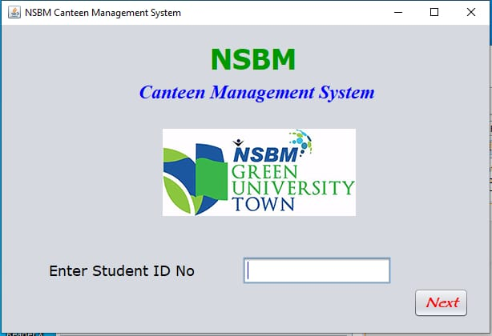

If you already have an account of canteen management system, you have to top-up your card to enter in to this system , when you enter your student index number the data will be pass to the database and check the values. If the data match with the database, the user can enter in to this system.

* We were use Getters and Setters method for our main interface.
* First, we get text for the “Next” button and check text field is empty or not.
* If text field is empty and click on “Next” button, we can see “Please Enter Your Student ID Number” display on the message box.
* When students enter their student ID numbers and click on “Next” button only they can move to the welcome page (food menu).

**Panel Window (Welcome Page)**

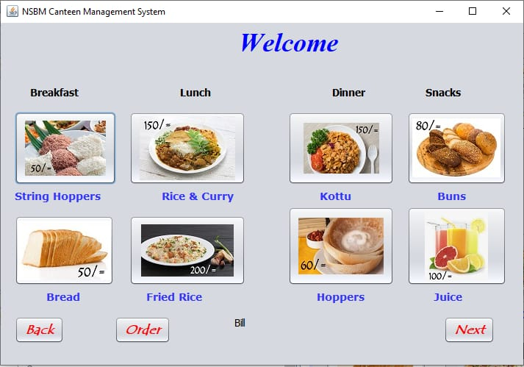

First you can order what you want, press “order” button. Then data will be pass to the database and the system will be make the bill. Where you received the bill, you have to go to login form and press the “back” button. If you want to move on to another page, press “next” button.

* We were use Getters and Setters method for welcome page.
* First we add buttons to food items and we change their variable names with using foods names. And we add a label and change it “variable name” to “bill”. And when student click on the food button display food item with price in “bill” label.
* We were get text and set text for each food button use their food name with price and assign them to “bill” label.

Eg : string bill = jLabel14 . getText ();

bill friedRice . getText ();

jLabel14 . setText (“fried Rice 200/=’);

When student click a button that food name and price will display on “bill” label.

**Diagrams**

**Interface of CRUD Operation in NSBM Canteen Management System**

CRUD operations

CRUD operation is an acronym from computer programming, which refers to the four functions that essential to implement a persistent storage application:

* Create
* Read
* Update
* Delete

**Create Function**

This function allows the admin to create a new record in the database. The Create function is called INSERT in the SQL database application. The admin can log in to the database, then create a new row and fill it with data that relates to each attribute, only admin is allowed to do so.

The system we designed clearly allowed admin to add new food items daily arrived to the cafeteria and this data entry comes along with the quantity and price of each food item. In the system we let admin to create new rows and columns in order to add new food items which were not available at the canteen management database up to the date.

**Read Function**

This function allows users to search, retrieve specific records in the table and read values of them. Users may be able to find wanted records using keywords, or by filtering the data based on customized basis.

Here the admin is allowed to read what available in the database. At This Point he may be able to search for results by filtering the data based on customized basis.

**Update Function**

This function is used to modify existing records that exist in the database. Users may have to modify information in multiple fields to fully change a record.

If prices of the food items or the items it self needs to be change or if the available quantity of the item changes it can be done by using update. Also the admin decides to replace a food with something different. Accordingly the existing record in the database must be changed and all of the attribute values changed to reflect the characteristics of the new food.

**Delete Function**

Here the system allows admin to remove unwanted records from a database. A “hard delete” permanently removes records from the database, while a “soft delete” simply update the status of a row to indicate that it has been deleted while leaving the data present and intact.

Where a food item is *out of order* or its *not available* at the moment, it must be removed from the system database. To do so and maintain the quality of the system we are using “delete” function.

**Exception Handling**

An exception is an event occurs during the execution of a program. Since this disrupts the normal flow of the program's instructions rise as an issue during a program’s execution. The Java uses exceptions to handle errors and other exceptional events. When an error occurs within a method, the method creates an exception object which contains information about the error, including its type and the state of the program when the error occurred. Creating an exception object and handing it to the runtime system in order to searches the call stack for a method that contains a block of code that can handle the exception. This block of code is called an exception handler which is to catch the exception. It is essential to mention that we are using this exception handling as a mechanism to the project.

**Input Data and Validation of Canteen Management System**

* All the validations for input value on the module canteen, sales, products.
* Orders, Items, Food can’t be submitted without filling all the in out fields.
* Duplicate values testing has been implemented on Canteen, Products, Food
* Canteen, Orders, Items, Sales, Products and Food has integrated with captcha for spam protections.
* Access level validation implemented on Food items and Orders, also number, character validation implemented on Products, Items, Canteen
* CSRF (Cross-Site Request Forgery) token implemented on Orders, Sales, Canteen, Items, Food.

Cross-site request forgeries are a type of malicious exploit whereby unauthorized commands are performed on behalf of an authenticated user. CSRF Token also known as Synchronizer Token is used to verify that the authenticated user is the one actually making the requests to the application.

**Reference**

https://www.sumologic.com/glossary/crud/

Lecture Notes

|  |  |  |  |
| --- | --- | --- | --- |
| **Plymouth ID No** | **Name** | **Workload** |  |
| 10707355 | M.T.D Salgado | Login Page, Food Menu Page & GUI Designing |  |
| 10707271 | Jayawardene Arachchige Ridmi | Create Data & Reporting |  |
| 10707188 | Wakwella Dushmantha | Show Data |  |
| 10707286 | Muthupahane Gedara Methma | Update Data |  |
| 10707275 | L.D Mandira | Delete Data & Diagrams |  |